- In the EAC, navigate to Mail flow > Send connectors, and then click Add .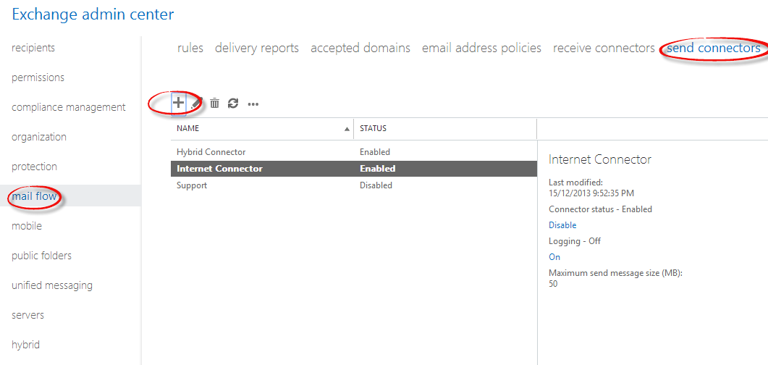
- In the New send connector wizard, specify a name for the send connector and then select Internet for the Type. Click Next.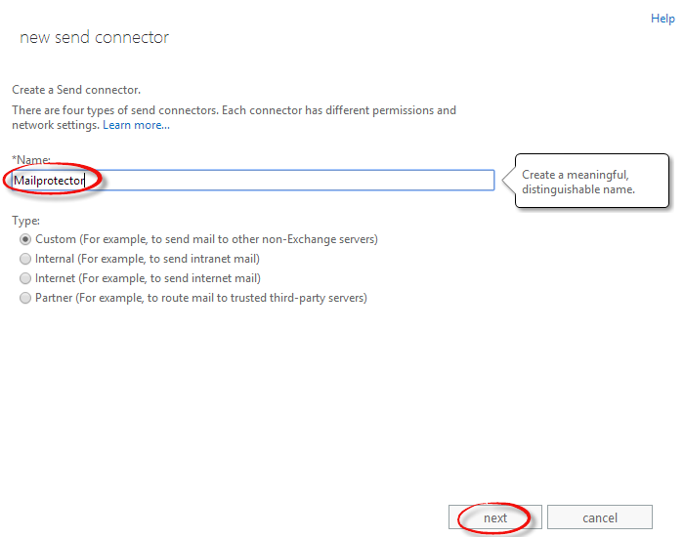
- Select Route mail through smart hosts. Click the plus sign and add the FQDN target using the format<yourdomain.com>.outbound.mailprotector.net (example: contoso.com.outbound.net). Save and Click Next.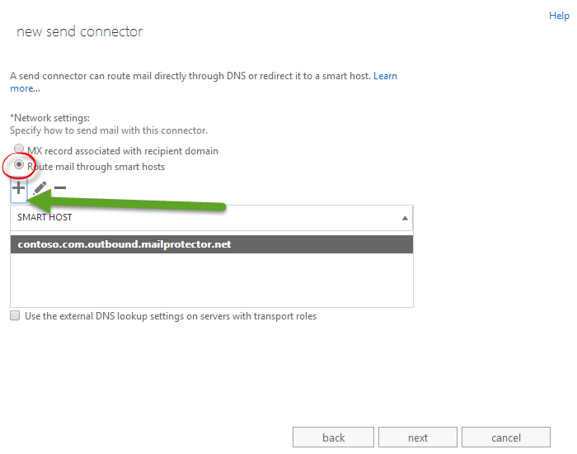
- Under Address space, click Add . In the Add domain window, make sure SMTP is listed as the Type. For Fully Qualified Domain Name (FQDN), enter *, which indicates that this send connector applies to messages addressed to any domain. Leave the *Cost set at 1 and the *Type set at SMTP. Click Save.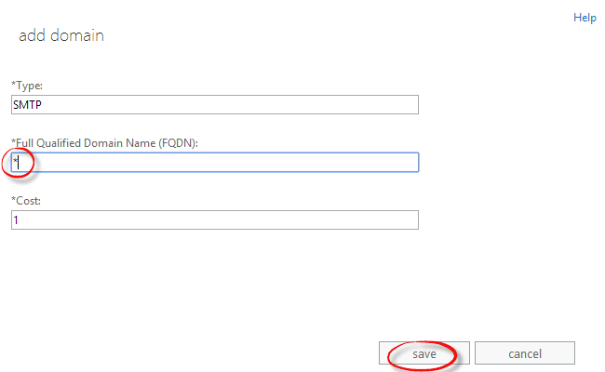
- Make sure Scoped send connector is not selected and then click Next.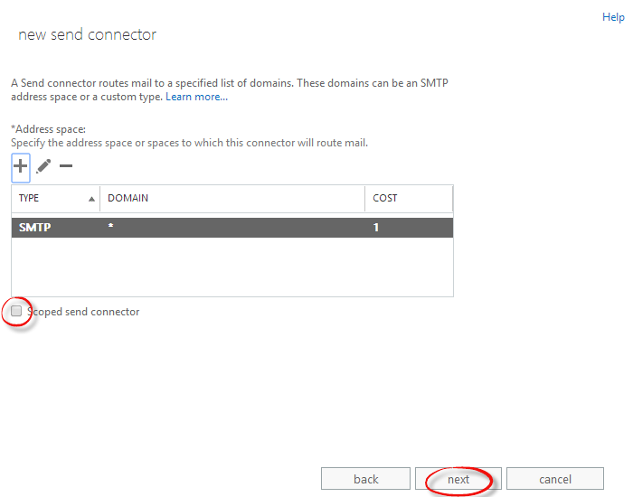
- For Source server, click Add . In the Select a server window, select a Mailbox server that will be used to send mail to the Internet via the Client Access server and click Add . After you've selected the server, click Add . Click OK.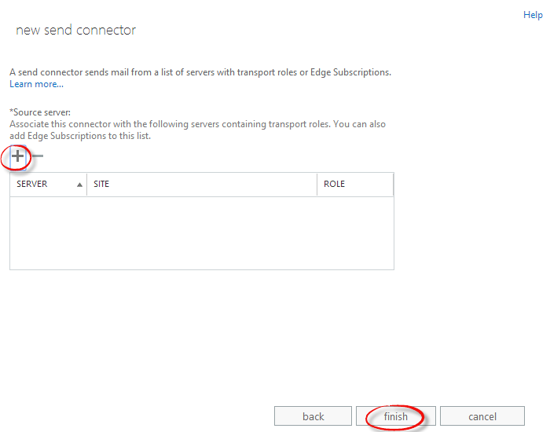
- Click Finish.

